Online Review Scorecard Admin Deployment Document



Revision History
Author | Revision Number | Date
albertwang | 0.1 | 2006-7-26
flying2hk | 0.2 | 2006-8-8

Deployment Instructions 3
1. Environment Setup 3
1.1 Organization of Repository 3
1.2 Application Server Setup 3
1.3 Email Service Setup 3
1.4 Directory Setup 3
1.5 Security Setup 3
1.6 Database Setup 4 4
1.7 Third Party Software Setup 4
1.8 Load Balancer Setup 4
1.9 Web Server Setup 4
2. Application Setup 4
2.1 Configuration Files 4
2.2 Template Setup 5
2.3 Build Scripts Setup 5
3. Detailed Instructions 5
4. Verification 5
5. Resource Contact List 5
6. Useful Documents 5
7. Useful Links 5

Deployment Instructions

Environment Setup

Organization of Repository
The deployment distribution is organized as follows:
- /src/java
Contains the Java source code of the application
- /src/sql
Contains the SQL scripts.
- DeploymentGuide.doc
Deployment Guide documentation.
- /web
Contains the JSP pages, JavaScript files, images and CSS style sheets.
- /WEB-INF
Contains webapp configuration files, including web.xml, struts-config.xml, struts TLDs.
- /conf
Contains the general configuration files for the Java code and dependency components.
- /lib
Contains the libraries used in the application
- /build.xml
Build script.

One thing to be noted is that in the deployment distribution, there’re mock Login/Logout actions and related JSP pages:

com.cronos.onlinereview.actions.MockLoginAction
com.cronos.onlinereview.actions.MockLogoutAction
com.cronos.onlinereview.actions.MockLoginForm
web/login.jsp
web/welcome.jsp

Those files are actually not materials of this assembly, but only helpers.

Application Server Setup

Install JBoss 4.0.2

Setup a new JBoss configuration
Simply setup a new configuration, no special configuration is needed.

Email Service Setup
N/A

Directory Setup
N/A

Security Setup
N/A

Database Setup

Create a new database in Informix with buffered log.

Execute SQL scripts under directory /src/sql in the following order:
Create.sql (create tables for Online Review application)
Lookups.sql (create lookup values for Online Review application, e.g. scorecard status, etc)
Sequences.sql (Create ID sequences for Scorecard Management componet)

Note that the following two scripts are used to clear or drop the tables when we need clear the environment(DO NOT execute them if you want to setup the DB):
Drop.sql (drop the tables)
Clear.sql(clear the tables, not drop them)

Third Party Software Setup
Struts 1.2.9 is used in this application, all we need is to copy the struts JAR and its dependencies(Apache libraries) to the library directory of the application.

Load Balancer Setup
N/A

Web Server Setup
N/A

Application Setup

Configuration Files

Configuration file for ScorecardActionsHelper( /conf/com/cronos/onlinereview/actions/ScorecardActionsHelper.xml)
The following informations are configured in this configuration file:
- Lookup values
Scorecard Types, Scorecard Statuses, Project Categories, Project Types, Question Types
- Ajax Support Application URL
- Name of the session attribute in which the user ID is stored.

The following table shows the configuration parameters, for details of the Object Factory configuration, please see configuration file /conf/com/cronos/onlinereview/actions/ScorecardActionsHelper.xml.

Parameter Name | Parameter Description | Parameter Default Value | Suggested Setting
objectSpecsNamespace  (Required) | Object Factory namespace from which the lookup values will be created | None | com.cronos.onlinereview.actions.  ScorecardActionsHelper.ObjectFactory
ajaxSupportAppUrl  (Required) | Ajax Support Application URL | None | http://localhost:8080/Online_Review/ajaxSupport
userIdSessionAttributeKey  (Required) | Name of the session attribute in which the user ID is stored | None | UserID
projectTypes.objectKey  (Required) | Object key of the project types object factory configuration | None | projectType
projectTypes.objectIdentifiers  (Required) | Object Identifiers of the project types object factory configuration | None | 1, 2
projectCategories.objectKey  (Required) | Object key of the project categories object factory configuration | None | projectCategory
projectCategories.objectIdentifiers  (Required) | Object Identifiers of the project categories object factory configuration | None | 1, 2, 3, 4, 5, 6, 7, 8, 9, 10, 11, 12, 13,14
scorecardTypes.objectKey  (Required) | Object key of the scorecard Types object factory configuration | None | scorecardType
scorecardTypes.objectIdentifiers  (Required) | Object Identifiers of the scorecard Types object factory configuration | None | 1, 2,3
scorecardStatuses.objectKey  (Required) | Object key of the scorecard statuses object factory configuration | None | scorecardStatus
scorecardStatuses.objectIdentifiers  (Required) | Object Identifiers of the scorecard statuses object factory configuration | None | 1, 2
questionTypes.objectKey  (Required) | Object key of the questionTypes object factory configuration | None | questionType
questionTypes.objectIdentifiers  (Required) | Object Identifiers of the questionTypes object factory configuration | None | 1, 2,3, 4, 5

Component Configurations
The following components need to be configured properly:
- DB Connection Factory (conf/com/topcoder/db/connectionfactory/DBConnectionFactoryImpl.xml)
- Scorecard Management & Scorecard Management Persistence(conf/com/topcoder/management/scorecard/ScorecardManager.xml)
- Logging Wrapper(conf/com/topcoder/util/log/LoggingWrapper.xml)
- Online Review Ajax Support (conf/com/cronos/onlinereview/ajax/default.xml and objectfactory.xml)
All required configurations are preloaded(as configured in configuration file conf/com/topcoder/util/config/ConfigManager.properties), generally, the only thing need to be changed at the deployment time is the Database connection information which is configured in conf/com/topcoder/db/connectionfactory/DBConnectionFactoryImpl.xml.

Web App configuration
Web.xml is located at /web/WEB-INF/web.xml

Struts configuration
The struts configuration file is located at /web/WEB-INF/struts-config.xml

Template Setup
N/A

Build Scripts Setup
The build script is located at the root directory of the deployment distribution (build.xml).

Target “compile” – compile the code
Target “compile_tests” – compile test code
Target “test” – execute unit tests.
Target “dist” – package the web app WAR file
Target “deploy” – copy the WAR file to JBoss deploy directory

Detailed Instructions
Execute “ant test” to execute the unit tests.

Execute “ant deploy” to automatically deploy the application, please make sure JBoss server has been setup and the configuration files and build.xml have been modified with appropriate values.

Verification
At the assembly time, we have no Login Tool in hand, so we created simple mock login & logout actions and the related JSP pages.
After deployment, visit URL like http://localhost:8080/Online_Review/login.jsp , enter a valid number as your user ID, click “Submit” (See figure 1). Then you will be guided to a welcome page(See figure 2), follow the link on that page, you can access the scorecard administration system and create/view/edit/copy scorecards. Note that you can logout by clicking the “Logout” link at the upper right corner.

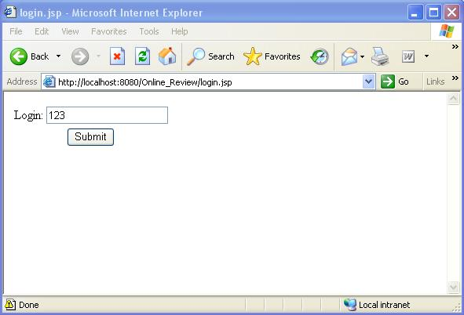
Figure 1
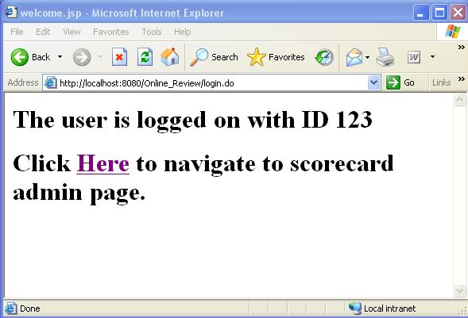
Figure 2
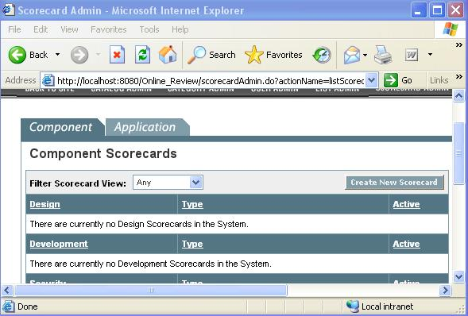
Figure 3

Resource Contact List
N/A

Useful Documents
N/A

Useful Links
N/A

